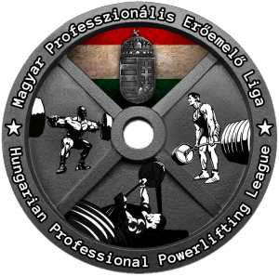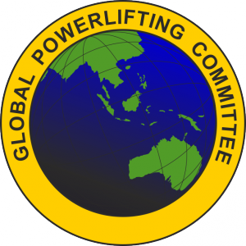

GPC World Championships
Powerlifting, Benchpress, Squat, Deadlift
RAW & EQUIPPED
16-23. September 2018.

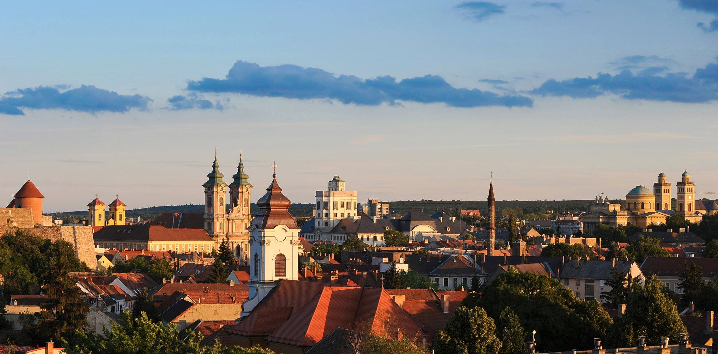

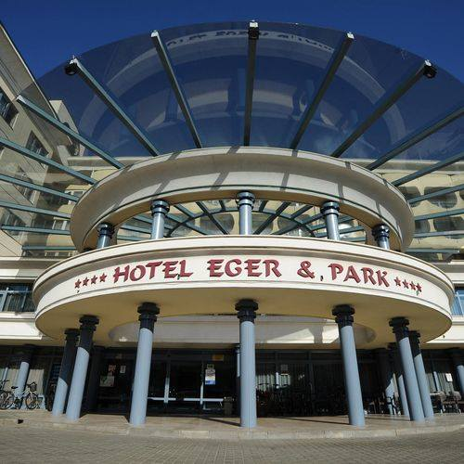
Basic Information
Host City | Eger, Hungary
Venue | Hotel Eger&Park  Eger, Szálloda utca 1-3. 3300 Hungary +36/36-522-200  GPS: N47.897118 E20.376162  www.hotelegerpark.hu info@hotelegerpark.hu
Organizers | - Hungarian Professional Powerlifting League  - Global Powerlifting Committee (GPC)
Technical Director  Promoter  Meet Director | Freimann Sándor  Hajdú László
Contact | 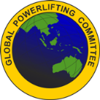  Rohrmann Katalin Anita Mahony  hungarianpowerliftingcongress@gmail.com World GPC Secretary  worldgpcsecretary@gmail.com  +36-20-241-8587 +353 86 8422018
Date | 16th to 23th of September 2018 (Sunday to Sunday)
Closing Date | 15th of August 2018. The entries will be accepted if the team list & fees are sent by the national federation to both e-mail addresses: hungarianpowerliftingcongress@gmail.com & worldgpcsecretary@gmail.com  and the entry fee is lodged to the bank account by the closing date.
Website | www.powerlifting.hu www.worldgpc.com www.gpcworld2018.com
Entry fees | - 64 EUR for first event entered (teenager and junior only 44 EUR).  - 35 EUR per additional event entered.  - Late entries will be accepted but with a penalty of 30 EUR per person which is also applied to entries received without entry fee by the closing date.
Categories | All GPC Weight & Age Categories – Male & Female  Teenage: 13-15; 16-17; 18-19 years; Junior: 20-23 years; Open (Senior): 24-39 years; Sub Master: 33-39 years (for record purposes only)  Master: 40-44 44; 45-49; 50-54; 55-59; 60-64;65-69; 70-74; 75-79; 80 years upward  Rulebook: www.worldgpc.com  RAW and EQUIPPED  Paralympic* - Lifters competing in this category must be able to use the standard lifting equipment as the GPC does not have specialised equipment. Lifters who cannot complete the lifts as per GPC rules and who have a disability, must enter the Paralympic category for their Age/Weight division. Lifters with a disability who can complete the lifts as per the GPC rules can opt to lift in the Paralympic category or standard category.  Disciplines:  Equipped (Multi-ply) RAW  - Powerlifting, - Powerlifting  - Benchpress - Benchpress  - Deadlift - Deadlift  - Squat - Squat

Bank Account Details
Bank details:
Bank: Kisalföld Takarék Szövetkezet
Adress of the bank: H-9200 Mosonmagyaróvár, Palánk u. 8.
SWIFT: TAKBHUHB
Owner: Hungarian Powerlifting Congress 7
Owner’s adress: H-9200 Mosonmagyaróvár, Kálnoki u. 11.
IBAN: HU82 5950 0155 5001 3667 0000 0000

Weigh in Times
Daily: 9.00-11.00 h & 15.00-18.00 h
Weigh in times may be modified after the application deadline to facilitate large number of entries
All weigh-ins take place the day before lifting commencing 15th September.
There will be no weigh-ins on the day of lifting!

Lifting Schedule
Lifting Commences every day at 9am unless otherwise indicated
Opening Ceremony – Sunday 16th at 8.30am
Sun | 16/09/18 | EQ Powerlifting & Raw Squat | All lifters
Mon | 17/09/18 | Raw Powerlifting | All Women &  Men up to -67.5
Tues | 18/09/18 | Raw Powerlifting | Men -75 & -82.5
Wed | 19/09/18 | Raw Powerlifting  AGM | Men -90 & -100
Thurs | 20/09/18 | Raw Powerlifting  EQ Squat | Men -110 to 140+  All lifters
Fri | 21/09/18 | EQ Bench & EQ Deadlift | All lifters
Sat | 22/09/18 | Raw Benchpress  Banquet | All Women &  Men up to -110
Sun | 23/09/18 | Raw Benchpress  Raw Deadlift | Men -125 to+140  All Lifters

Hotel
Hotel Eger & Park
Website | www.hotelegerpark.hu
Booking | info@hotelegerpark.hu Rooms must be booked directly with the Hotel. Please write “GPC World” as the booking password when making reservation.
Address | Eger, Szálloda utca 1-3. 3300 Hungary
e-mail | info@hotelegerpark.hu
Phone | +36-36-522-200 +36-36-522-221
Parking | Beside the hotel
Alternative Accommodation
- www.szallas.hu/Eger/
- www.booking.com/eger
- www.trivago.hu/Szállás/Eger
- www.szallas.eger.hu
- www.szallasinfo.hu/szallasok/eger.php
- www.travelminit.hu/en

Enclosures – Entry Form & Team List
- Team List - All lifters must submit their entry forms and entry fees (with the exception of Individual GPC Members from Non-Affiliated Countries) to their National Federation to be included on that Country’s team list. This team list is to be returned by email to: hungarianpowerliftingcongress@gmail.com & worldgpcsecretary@gmail.com & the entry fee paid by the National Federation in Euro to the organiser by 15. 08. 2018.

Eligibility
All lifters must be members of the GPC. Each nation sets their own entry requirements.
Lifters must enter through their national federation.
Lifters from countries which are not members of the GPC, can apply for Individual Membership of
the GPC (Form available on GPC website).
http://www.worldgpc.com/index.php/downloads

Visas
If you require a visa compete in these championships, please complete the VISA Support Letter Form available under downloads on the GPC website (http://www.worldgpc.com/index.php/downloads) and return to the World GPC Secretary. Lifters must be members of the GPC affiliate in their country or if from a country which doesn’t have a GPC affiliate, must join as individual GPC members before requesting a VISA Support Letter. Individual Membership forms are also available under downloads on the GPC Website.

Airport Transfers
Airport - Budapest - Eger 140 km

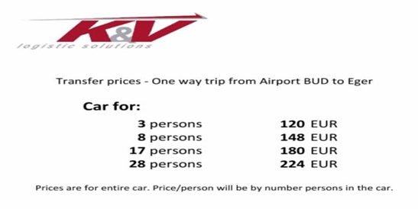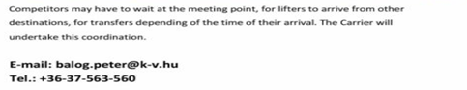
See you in Eger!

